Data Flow Diagram (DFD) Design
Introduction
The Data Flow Diagrams (DFDs) models how data moves through the Malware Detection and Remediation System. They provide a structured view of system, external entities, internal processes, and data stores, without exposing the complex implementation-level details. Two DFD levels are used in this design: a Context Level 0 DFD, which shows a high-level view of the system, and a Decomposition Level 1 DFD, which expands the core system into its primary internal functions.

Context Level 0 Data Flow Diagram
The Context Level 0 DFD shows the entire Malware Detection and Remediation System as a single process and defines how the core system interacts with external entities. At this level, the internal structure of the system is abstracted to focus on the system’s core entities and high-level data flows.
The system interacts with four external entities: the end-user, the host system, the SQL database, and the Cuckoo Sandbox API. The end-user initiates scan requests and receive the results of completed scans. The host system provides file paths to be scanned. The SQL database serves as a central knowledge base, storing malware signatures, detection rules, remediation information, and scan results. The Cuckoo Sandbox API supports dynamic analysis by receiving suspicious files or hashes and returning behavioural reports and indicators of compromise (IOCs)

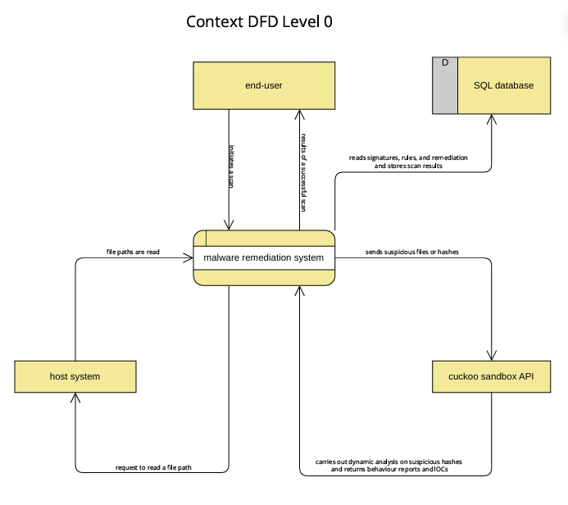
Decomposition Level 1 Data Flow Diagram
The Decomposition Level 1 DFD expands the core system process shown in the context diagram into its main internal processes. The decomposition level illustrates how scan requests are handled internally and how static and dynamic detection mechanisms interact with external components.
At this level, the system is decomposed into different processes responsible for managing scan requests, reading file paths from the host system, performing YARA-based static analysis, and dynamic analysis through the Cuckoo Sandbox API. File paths are scanned using static detection rules retrieved from the SQL database. When suspicious artefacts are identified, hashes or files are submitted to the sandbox for behavioural analysis. The resulting behaviour reports and IOCs are then used to support malware detection decisions.
Detection records and scan metadata are stored in the SQL database. The system retrieves remediation guidance from the database and presents it to the end-user following a successful detection. This level of the DFD demonstrates how data flows between detection, analysis, storage, and remediation components in a structured and sequential manner.

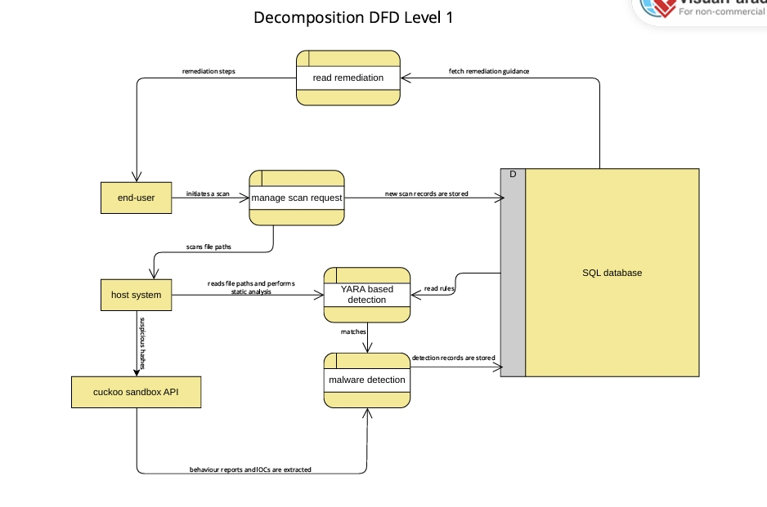

Conclusion
The two DFD levels are consistent and complementary. The Context Level 0 DFD defines the external view of the system and its primary data exchanges, while the Decomposition Level 1 DFD provides greater detail on how internal detection and remediation processes operate. Together, they offer a clear and progressive understanding of the system’s data flows, supporting both high-level design reasoning and detailed system analysis.

